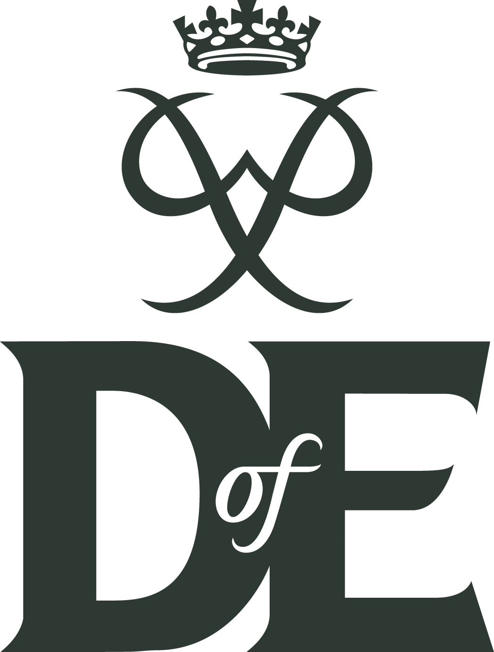 | The Scout Association | 

Duke of Edinburgh’s Award Participants Registration Form (2025-Rev01)

Please print clearly in CAPITALS, and complete all the sections. It is especially important that your name and email address are legible!

Personal details |  | Explorer Unit:
Title: Mr/Miss/Mrs/Ms/Other |  | Home address
First name:
Last name:
Male/Female: |  | Home postcode:
Date of birth: |  | Phone (home):
Age: |  | Phone (mobile):
Email address (participant) – this is the email address to which log-in details will be sent:

Email address (parent) - optional:
Enrolment level (tick or circle one): | Bronze | Silver | Gold
I give permission for my Explorer Leader to share my OSM profile with District OSM DofE Account |  |  | Opt Out

Previous levels/sections – please tick any levels/sections you have completed:
Bronze | Date awarded: | Volunteering | Physical | Skills | Expedition
Silver | Date awarded: | Volunteering | Physical | Skills | Expedition
eDofE number: |  | Previous Award group (school or other organisation):

Consent to enrolment from parent or guardian (if applicant is under 18 years old).
I agree to my son/daughter/ward participating in the Duke of Edinburgh’s Award. I understand that unless the activity is organised by the Scout Association, it is my responsibility to check that any activity my son/daughter/ward undertakes for their Duke of Edinburgh’s Award is appropriately managed and insured.
Parent/guardian | Name | Signature | Date
I agree to enrol as a Duke of Edinburgh’s Award participant. [You will be doing your programme using our online eDofE system. This system has a set of terms and conditions that you must agree to. These are available at www.eDofE.org/terms.aspx (pdf document)]
Applicant | Name | Signature | Date

When you first sign in to eDofE you will be asked to record some personal details such as your contact details, ethnicity and personal circumstances along with details of any medical needs you may have. This data is used to enable your Leaders to support you doing your DofE programme and for the DofE’s statistical and reporting purposes. You will always have a ‘prefer not to say’ option.
Send completed form via email (preferred) to: dofe@somersetscouts.org.uk.
Payment to Somerset County Scout Council, for £30.50 for Bronze or Silver, or £37.50 for Gold, via BACS – Account Name: Somerset County Scout Council, Sort Code: 30-98-45,Account: 01787278, Reference: DofE 2025- name. Registration will not be actioned until payment is confirmed by the Treasurer
For further information and advice, please contact: dofe@somersetscouts.org.uk

Data supplied on this form and in eDofE, and information about DofE activities recorded in eDofE will be used by the DofE Charity, the Licensed Organisation and DofE centre to monitor and manage DofE participation and progress by young people and to manage and support Leaders. Contact with participants about their Awards will be via the eDofE messaging system or by email. If an email is sent to a participant under the age of eighteen, their leader and also their parent will be copied into the email.

The DofE Charity will use personal data to communicate useful and relevant information to either help participants complete a DofE programme, Leaders/LOs to run DofE programmes more effectively, or help the DofE Charity to improve the quality and breadth of its programmes.

We also send emails that contain information about the Charity, DofE negotiated privileged discounts and invitations to events and other activities; however if you would like to receive these emails you will need to opt in. Once you have opted-in to this you can opt out at any time by visiting www.dofe.org/preferences, or clicking the unsubscribe link that can be found at the bottom of all non-programme related email.

